***Dt : 20/8/2022***

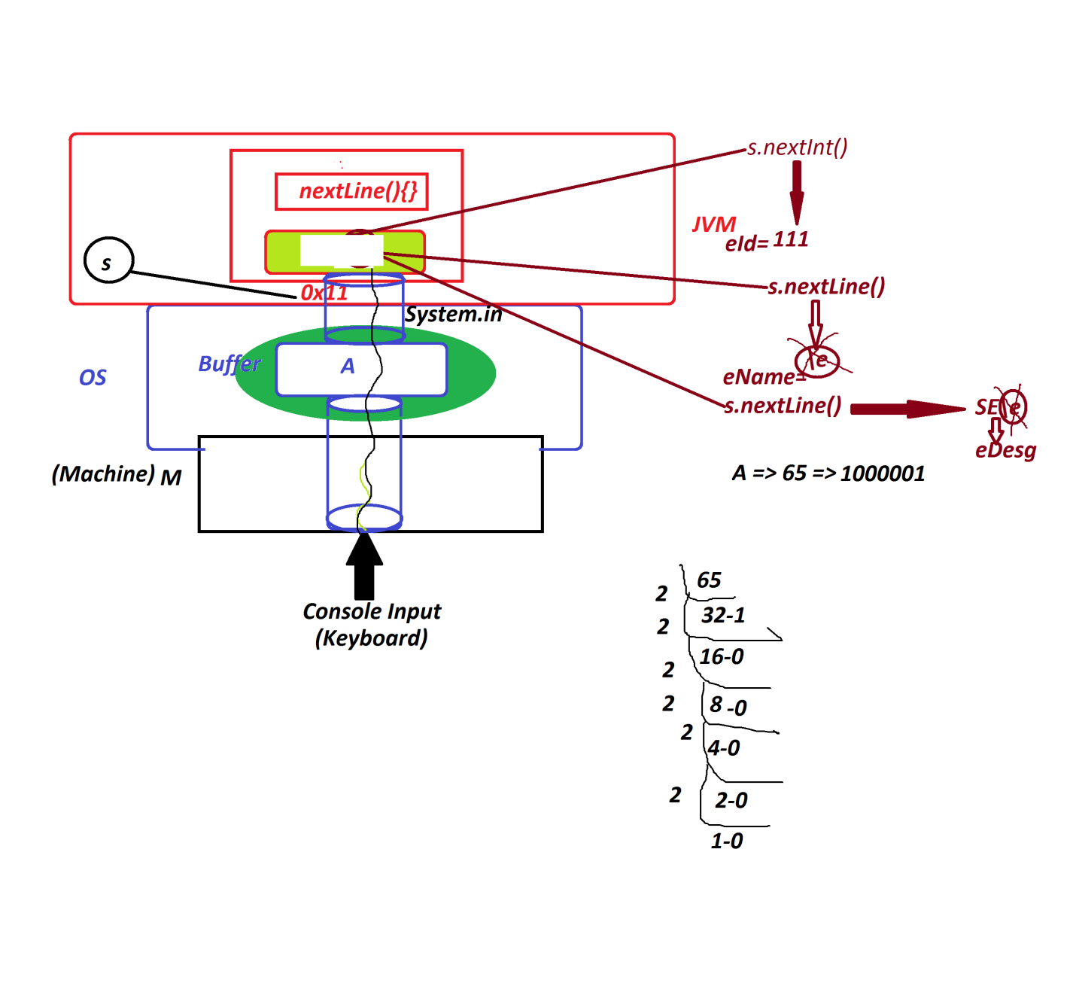

***Assignment:(Solution)***

***wap to read and display Employee details with address?***

***(eId,eName,eDesg,hNo,sName,city,pinCode)***

***DemoMethods5.java***

***import java.util.Scanner;***

***class DemoMethods5***

***{***

***public static void main(String[] args)***

***{***

***Scanner s = new Scanner(System.in);***

***System.out.println("Enter the empId:");***

***int eId = Integer.parseInt(s.nextLine());***

***System.out.println("Enter the EmpName:");***

***String eName = s.nextLine();***

***System.out.println("Enter the EmpDesg:");***

***String eDesg = s.nextLine();***

***System.out.println("Enter the EmpHNo:");***

***String hNo = s.nextLine();***

***System.out.println("Enter the EmpStreetName:");***

***String sName = s.nextLine();***

***System.out.println("Enter the City:");***

***String city = s.nextLine();***

***System.out.println("Enter the PinCode:");***

***int pinCode = s.nextInt();***

***System.out.println("=====DisplayDetails====");***

***System.out.println("EmpId:"+eId);***

***System.out.println("EmpName:"+eName);***

***System.out.println("EmpDesg:"+eDesg);***

***System.out.println("EmpHNo:"+hNo);***

***System.out.println("EmpSName:"+sName);***

***System.out.println("EmpCity:"+city);***

***System.out.println("EmpPinCode"+pinCode);***

***}***

***}***

***===========================================================***

***Note:***

***=>when we read String data after numeric data,the String data***

***will be Skipped.***

***=>This can be overcomed using the following parse methods,which***

***read the data in the form of String and convert into numeric.***

***byte b = Byte.parseByte(s.nextLine());***

***short st = Short.parseShort(s.nextLine());***

***int i = Integer.parseInt(s.nextLine());***

***long l = Long.parseLong(s.nextLine());***

***float f = Float.parseFloat(s.nextLine());***

***double d = Double.parseDouble(s.nextLine());***

***=========================================================***

***\*imp***

***Operators in Java:***

***=>Operators are the special symbols used to perform operations.***

***=>The following are some important operators used in Java:***

***1.Arithmetic Operators***

***2.Relational Operators***

***3.Logical Operators***

***4.Increment-Decrement Operators***

***1.Arithmetic Operators:***

***=>Arithmetic Operators are used to perform basic operations***

***or fundamental operations.***

***Operator Meaning***

***+ Addition***

***- Subtraction***

***\* Multiplication***

***/ Division***

***% ModDivision***

***2.Relational Operators:***

***=>Relational operators are used to compare two values and***

***generate boolean result***

***Operator Meaning***

***> Greater Than***

***>= Greater Than or Equal***

***< Less Than***

***<= Less Than or Equal***

***== Is Equal to***

***!= Not Equal to***

***3.Logical Operators:***

***=>Logical operators are used to compare two comparisions and***

***generate boolean result.***

***Operator Meaning***

***&& Logical AND***

***|| Logical OR***

***! Logical NOT***

***Logical AND(&&):***

***A B A&&B***

***T T T***

***F T F***

***T F F***

***F F F***

***Logical OR(||):***

***A B A||B***

***T T T***

***F T T***

***T F T***

***F F F***

***Logical NOT(!):***

***A !A***

***T F***

***F T***

***4.Increment-Decrement Operators:***

***=>Increment operator will increment the value by 1 and***

***decrement operator will decrement the value by 1.***

***Operator Meaning***

***++ Increment***

***-- Decrement***

***=======================================================***

***\*imp***

***Control Structures in Java:***

***=>The structures which are used to control the part of the***

***program are known as Control Structures.***

***=>These Control Structures are categorized into the following:***

***1.Selection statements***

***2.Iterative statements***

***3.Branching statements***

***1.Selection statements:***

***=>The statements which are used to select some part of program***

***for execution are known as Selection Statements.***

***=>Types:***

***(a)simple if***

***(b)if-else***

***(c)Nested if(Inner if)***

***(d)Ladder if-else***

***(e)switch-case***

***2.Iterative statements:***

***=>The statements which are used to execute some lines of***

***program repeatedly on some condition are known as Iterative***

***Statements or Repeatitive Statements or Looping Structures.***

***=>Types:***

***(a)while loop***

***(b)do-while loop***

***(c)for loop***

***3.Branching statements:***

***=>The statements which are used to transfer the execution***

***control from one location to another location are known as***

***Branching Statements or Transfer Statements.***

***=>Types:***

***(a)break***

***(b)continue***

***(c)exit***

***(d)return***

***Note:***

***=>'goto' statement if not available in Java.***

***====================================================***

***Ex:***

***wap to read three integer values and perform the following***

***operations based on User choice:***

***1.Greater***

***2.Smaller***

***import java.util.Scanner;***

***class Greater***

***{***

***int compare(int x,int y,int z)***

***{***

***if(x>y && x>z)***

***{***

***return x;***

***}***

***else if(y>x && y>z)***

***{***

***return y;***

***}***

***else***

***{***

***return z;***

***}***

***}***

***}***

***class Smaller***

***{***

***int compare(int x,int y,int z)***

***{***

***if(x<y && x<z)***

***{***

***return x;***

***}***

***else if(y<x && y<z)***

***{***

***return y;***

***}***

***else***

***{***

***return z;***

***}***

***}***

***}***

***class DemoMethods6***

***{***

***public static void main(String[] args)***

***{***

***Scanner s = new Scanner(System.in);***

***System.out.println("Enter the int value1:");***

***int v1 = s.nextInt();***

***System.out.println("Enter the int value2:");***

***int v2 = s.nextInt();***

***System.out.println("Enter the int value3:");***

***int v3 = s.nextInt();***

***System.out.println("====Choice====");***

***System.out.println("1.Greater\n2.Smaller");***

***System.out.println("Enter the Choice:");***

***int choice = s.nextInt();***

***switch(choice)***

***{***

***case 1:***

***Greater gt = new Greater();***

***int r1 = gt.compare(v1,v2,v3);***

***System.out.println("GreaterValue:"+r1);***

***break;***

***case 2:***

***Smaller sm = new Smaller();***

***int r2 = sm.compare(v1,v2,v3);***

***System.out.println("SmallerValue:"+r2);***

***break;***

***default:***

***System.out.println("Invalid Choice....");***

***}//end of switch***

***}***

***}***

***o/p:***

***Enter the int value1:***

***12***

***Enter the int value2:***

***23***

***Enter the int value3:***

***11***

***====Choice====***

***1.Greater***

***2.Smaller***

***Enter the Choice:***

***1***

***GreaterValue:23***

***=========================================================***

***Assignment:***

***wap to read two integer values and perform the following***

***operations based on User choice:***

***1.add***

***2.sub***

***3.mul***

***4.div***

***5.modDiv***